Epic Games v. Apple Inc.

Name

Institution Affiliations

Course Title

Date

DO NOT USE ANOTHER/OUTSIDE SOURCE. THE DOCUMENT FILE 5 (THE READING: EPIC GAMES: NINETEEN- EIGHTY FORTNITE) THAT I SENT IS THE ONLY SOURCE THAT YOU CAN USE.

JUST ANSWER EACH QUESTIONS BASED ON THE INFORMATION FROM THE READING, AND YOU ELABORATE THAT INFORMATION BY GIVING YOUR THOUGHT AND EXPLANATION.

What is the "product" provided by the App Store? Who are the App Store customers?
In this case, the App Store provides a safe and secure platform, where app developers can securely upload apps for their users. The App Store also ensures that users have faith in the apps and transactions they make to acquire them. Therefore, it acts as a link between app developers and potential customers and users. The App Store customers are the developers, who engage in a contract or form of agreement with the App Store, which sells the apps to users on behalf of the developers. Previously, App Store never allowed app developers to contact app users on non-apple purchase options. However, App Store has changed its policies, and now app developers can obtain customer information such as emails from within the apps and communicate with potential customers and encourage them to use other payment methods such as direct payment instead of paying through Apple, (Bostoen, 2021).
Antitrust complaints require the court to define the relevant product market and, as noted in the case, both Epic Games and Apple offer their definitions. Briefly describe whether or not you think the following products should be included in the relevant product market in addition to iOS gaming apps:
- iOS non-gaming apps
The iOS non-gaming apps can be included in the relevant iOS relevant market. These non-gaming apps have their appropriate submarket and also create unique and competitive pressure for gaming apps despite that they differ with some form and degree of market competition. The addition of non-gaming apps can help maintain the gaming apps on toes, increasing their growth ability and hence creating a competitive advantage.
- other mobile gaming apps (e.g., Android, Nintendo Switch)
It might be disadvantageous to include other mobile apps in Apple’s relevant market because most of them, especially android comes along with advertisements and bugs which iOS do not like. (NEED MORE EXPLANATION)
- console games (e.g., PC, Xbox, PlayStation)
The market structure of console games is the oligopoly market structure. By including console games in the iOS relevant market can help reduce the virtual monopoly App Store has been enjoying for quite some time.
- cloud-based gaming
Cloud-based gaming models our current gaming market, with its revenue estimated to increase up to more than five billion US dollars by next year and technology advances. Cloud-based gaming is the best big thing that App Store should not hesitate to include in its relevant market. Online gaming services are live solely in the cloud, hence customers eliminate the need to buy, maintain or upgrade any gaming systems such as consoles. They don't also have to buy any extra gaming machines to play the games; hence it’s the ultimate goal for App Store.
Epic alleges that Apple illegally tied access to the App Store to the use of a second product, In-App Purchase. Are these two separate products? Based on our discussion of tying, is this an example of illegal tying?
The second product, that is, the iOS In-App Payment Processing Market is completely different from the first payment method used by App Store, that is, the iOS App Distribution Market. App Store undertakes the unlawful actions of creating a payment processing system that is part of two products to maintain a form of monopoly in its purchases, which allows App Store to take up to 30% revenue cut on App purchases made using the in-app purchase system.
This is a form of illegal tying that the App Store uses to continue with its unreasonable restraining of virtual trade between the app developers and customers. App Store has created a monopoly such that there is no way to distribute apps within iOS other than through the Store. Therefore, it may be viewed as a tie between the operating system (the tying product) and the App Store (tied product). By creating this tie, the result is that there remains no other way to pay for apps in the App Store than through IAP, which may be viewed as a tie between the app store (the tying product) and payment processing (the tied product). The App Store tying is considered illegal because it treats the products in question as separate products. The customers are unable to acquire the tying product with the tied one, hence creating a foreclosure in either the tying or the tied market, (Ambrasaitė and Smagurauskaitė, 2021).

Please change all this sentence to avoid plagiarism. Also, can you check your work to Turnitin before hand it to me. Also, send the Turnitin result to me. Thank you!
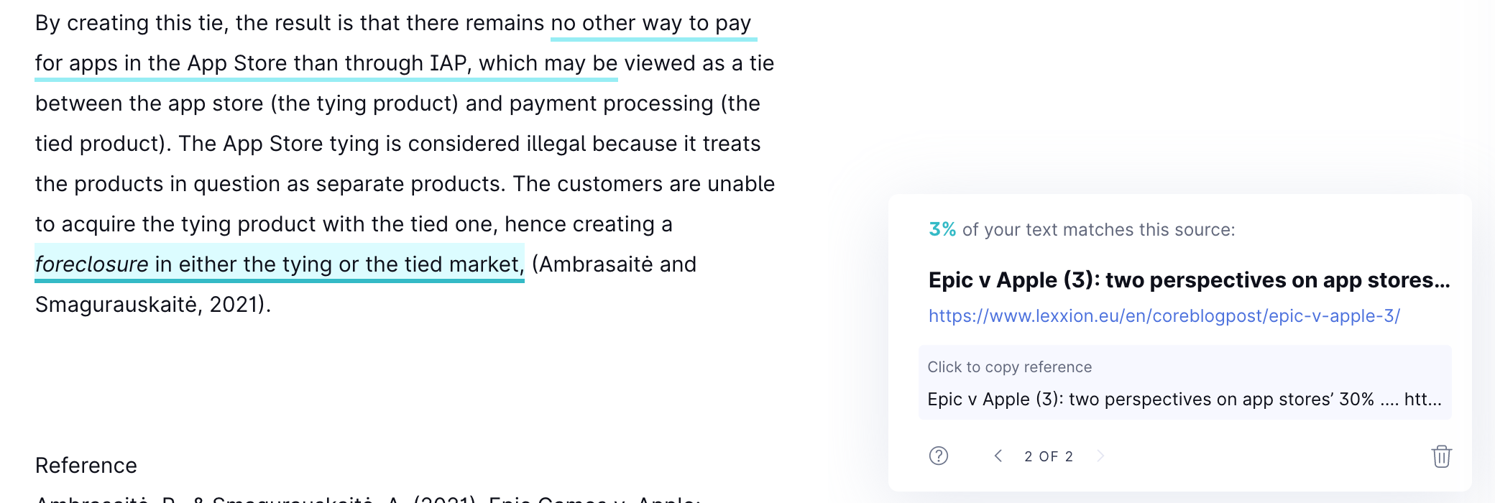
Reference
Ambrasaitė, P., & Smagurauskaitė, A. (2021). Epic Games v. Apple: Fortnite battle that can change the industry. Vilnius University Open Series, 6-25.
Bostoen, F. (2021). Epic v Apple: Antitrust’s Latest Big Tech Battle Royale. European Competition and Regulatory Law Review, 5(1), 79-85.

